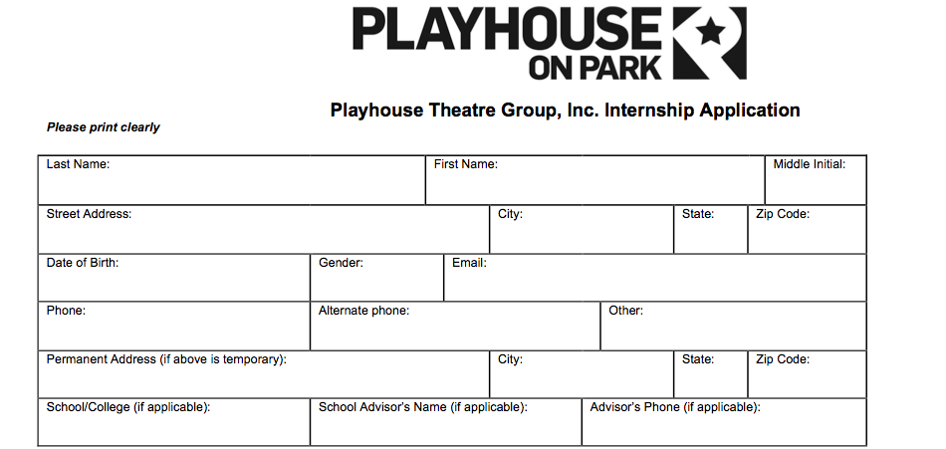

What level best describes your experience at this point *(circle one)*: **College Early Career**

**Internships are available in the following concentrations:** Company Management/Finance, Costumes, Education, Marketing, Technical Theatre and Stage Management.

* Which concentrations are you primarily interested in?
* Are you interested in any secondary concentrations?

Please also include with this application:

* A copy of your most recent resume
* Two letters of recommendation
* A personal statement. Personal statements should include experiences and influences that have contributed to your personal growth. In addition please address the following topics: your professional goals, how the internship will help you achieve these goals, and any unique contribution you will bring to Playhouse Theatre Group, Inc.
* Are you including a portfolio or examples of your work? (circle one) YES NO

If YES, please include links or attachments to your application.

**Application Deadline:** We recommend materials to be sent in *as soon as possible.* All materials *must be* received by **Friday, March 10th, 2023**

Internships will announced by:  **Monday, April 3rd, 2023**

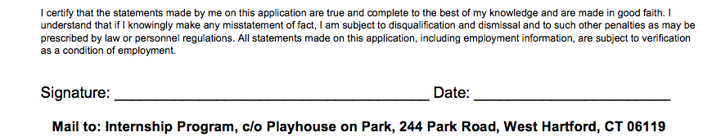

Please email your completed application packet to Jill Zarcone, Director of Education at [jzarcone@playhousetheatregroup.org](mailto:jzarcone@playhousetheatregroup.org).